**DAILY ONLINE ACTIVITIES SUMMARY**

|  |  |  |  |  |  |  |
| --- | --- | --- | --- | --- | --- | --- |
| **Date:** | | **21 June 2020** | | **Name:** | **KHATHEEJA SAFREENA.** | |
| **Sem & Sec** | | **4th sem, 2nd year** | | **USN:** | **4al18cs037** | |
| **Online Test Summary** | | | | | | |
| **Subject** | **----------------** | | | | | |
| **Max. Marks** | **----** | | **Score** | | **-----** | |
| **Certification Course Summary** | | | | | | |
| **Course** | | **INTRODUCTION TO INFORMATION TECHNOLOGY.** | | | | |
| **Certificate Provider** | | **GreatLearning** | **Duration** | | | **6 hours** |
| **Coding Challenges** | | | | | | |
| **Problem Statement:1 program** | | | | | | |
| **Status: Executed** | | | | | | |
| **Uploaded the report in Github** | | | **Yes** | | | |
| **If yes Repository name** | | | [http://shafreenasharief / lockdown-coding](http://shafreenasharief / lockdown-coding" \o "http://shafreenasharief / lockdown-coding)  [http://shafreenasharief / locked-down--certification-course](http://shafreenasharief / locked-down--certification-course" \o "http://shafreenasharief / locked-down--certification-course)  **[http://shafreenasharief / Daily\_Report](http://shafreenasharief / Daily_Report" \o "http://shafreenasharief / Daily_Report)** | | | |
| **Uploaded the report in slack** | | | **Yes** | | | |

Certification Course Details: (Attach the snapshot and briefly write the report for the same)

Coding Challenges Details: (Attach the snapshot and briefly write the report for the same)

**CERTIFICATION COURSE SUMMARY:**

Today I started new course **INTRODUCTION TO INFORMATION SECURITY** through **GREAT LEARNING** the course is secluded for 6hrs. After the completion of course, certificate will be provided. I completed all the module .I attempted quiz ,which gave me a clear veiw about the topics that were thought and discussed.It consists of 7 modules which also include assessments.

* **There is the snapshot of the certificate secured after completion of course.**



***CODING CHALLENGE :***

Today I solved 1 coding challenge,

1**. Write a Java program to count number of bits to be flipped to convert A to B** Given two numbers ‘a’ and b’. Write a program to count number of bits needed to be flipped to convert ‘a’ to ‘b’.

**Example:**

Input: a = 10, b = 20  
Output: 4  
Binary representation of a is 000**0101**0  
Binary representation of b is 00010100  
We need to flip highlighted four bits in a  
to make it b.

Input: a = 7, b = 10  
Output: 3  
Binary representation of a is 0000**01**1**1**  
Binary representation of b is 00001010  
We need to flip highlighted three bits in a  
to make it b.

**Hint**

1. Calculate XOR of A and B.  
   a\_xor\_b = A ^ B
2. Count the set bits in the above  
   calculated XOR result.  
   countSetBits(a\_xor\_b)

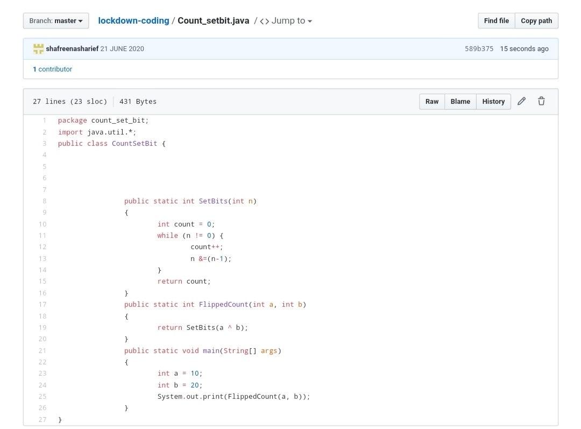

**SOLUTION** : I have uploaded the solution of the above 3 coding problems in my GitHub repository.

[http://shafreenasharief / lockdown-coding](http://shafreenasharief / lockdown-coding" \o "http://shafreenasharief / lockdown-coding)

[http://shafreenasharief / locked-down--certification-course](http://shafreenasharief / locked-down--certification-course" \o "http://shafreenasharief / locked-down--certification-course)

[http://shafreenasharief / Daily\_Report](http://shafreenasharief / Daily_Report" \o "http://shafreenasharief / Daily_Report)